**lists:**

An unordered HTML list:

* Item
* Item
* Item
* Item

An ordered HTML list:

1. First item
2. Second item
3. Third item
4. Fourth item

<ul>

<li>Coffee</li>

<li>Tea</li>

<li>Milk</li>

</ul>

<ol>

<li>Coffee</li>

<li>Tea</li>

<li>Milk</li>

</ol>

<ul style="list-style-type:disc;">

_disc

_circle

_square

_none

<html>

<head>

<style>

ul {

list-style-type: none;

margin: 0;

padding: 0;

overflow: hidden;

background-color: #333333;

}

li {

float: left;

}

li a {

display: block;

color: white;

text-align: center;

padding: 16px;

text-decoration: none;

}

li a:hover {

background-color: #111111;

}

</style>

</head>

<body>

<h2>Navigation Menu</h2>

<p>In this example, we use CSS to style the list horizontally, to create a navigation menu:</p>

<ul>

<li><a href="#home">Home</a></li>

<li><a href="#news">News</a></li>

<li><a href="#contact">Contact</a></li>

<li><a href="#about">About</a></li>

</ul>

</body>

</html>

Overflow:

div {

overflow-x: hidden; /* Hide horizontal scrollbar */

overflow-y: scroll; /* Add vertical scrollbar */

}

**Text decoration:**

<head>

<style>

h1 {

text-decoration: overline;

}

h2 {

text-decoration: line-through;

}

h3 {

text-decoration: underline;

}

h4 {

text-decoration: underline overline;

}

</style>

</head>

<body>

<h1>This is heading 1</h1>

<h2>This is heading 2</h2>

<h3>This is heading 3</h3>

<h4>This is heading 4</h4>

</body>

</html>

<ol type="1">

<li>Coffee</li>

<li>Tea</li>

<li>Milk</li>

</ol>

<ol type="A">

<li>Coffee</li>

<li>Tea</li>

<li>Milk</li>

</ol>

Span

<p>My mother has <span style="color:blue;font-weight:bold;">blue</span> eyes and my father has <span style="color:darkolivegreen;font-weight:bold;">dark green</span> eyes.</p>

**Div**

**<div style="background-color:black;color:white;padding:20px;">**

<h2>London</h2>

<p>London is the capital city of England. It is the most populous city in the United Kingdom, with a metropolitan area of over 13 million inhabitants.</p>

<p>Standing on the River Thames, London has been a major settlement for two millennia, its history going back to its founding by the Romans, who named it Londinium.</p>

**</div>**

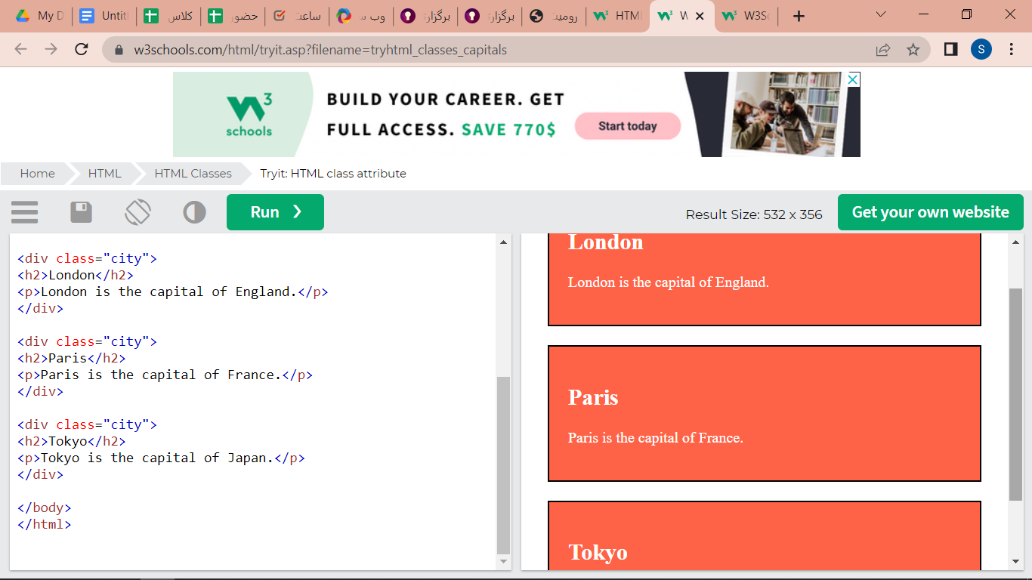

درست کردن دیو هایی که از یک کلاس مشترک استفاده میکنن

<!DOCTYPE html>

<html>

<head>

<style>

.city {

background-color: tomato;

color: white;

border: 2px solid black;

margin: 20px;

padding: 20px;

}

</style>

</head>

<body>

<div class="city">

<h2>London</h2>

<p>London is the capital of England.</p>

</div>

<div class="city">

<h2>Paris</h2>

<p>Paris is the capital of France.</p>

</div>

<div class="city">

<h2>Tokyo</h2>

<p>Tokyo is the capital of Japan.</p>

</div>

</body>

</html>

**Class in HTML:**

**<!DOCTYPE html>**

**<html>**

**<head>**

**<style>**

**.note {**

**font-size: 120%;**

**color: red;**

**}**

**</style>**

**</head>**

**<body>**

**<h1>My <span class="note">Important</span> Heading</h1>**

**<p>This is some <span class="note">important</span> text.</p>**

**</body>**

**</html>**